MS. Vassar’s TCAP Study Guide

TSW…

1. Classify organisms as producers, consumers, scavengers, or decomposers according to their **role** in a food chain or food web.

* Producers- user photosynthesis to make their own food---100% of sun’s energy—begin food chain
* Consumers- can NOT make their own food- predator/prey…10% of producer’s energy…primary consumer
* Scavengers-DO NOT KILL/HUNT…eat ALREADY dead animals…ex: vulture…10% of consumer’s energy…secondary or tierary consumer
* Decomposers- DO NOT HUNT OR KILL…break down dead decaying plant and animal matter---replenishes the soil…10% of scavenger’s energy nothing or almost nothing

1. Interpret how materials and energy are transferred through an ecosystem…

Through a food chain/web…consumption

By eating or absorbing/breaking down other things in the ecosystem

**Producers** get 100% of sun energy

**primary consumers** eat producers get 10% of producer’s energy

**secondary consumers** eat primary consumers get 10% of primary’s energy

**scavengers** eat dead animal remains get 10% of secondary’s energy

**decomposers-** break down dead and decaying plant and animal matter

1. Identify the biotic and abiotic elements of the major biomes.

**Abiotic**- NEVER were alive: water, soil, sunlight, air, temperature and rock

**Biotic**- Living or once was alive: people, animals, plants

1. Identify the environmental conditions and interdependencies among organisms found in the major biomes….

everything depends on something else…ultimately everything depends on the sun…sun, producers, consumers, scavengers, decomposers

1. Use data to draw conclusions about the major components of the universe.

Small and large bodies in the ss, rotation, revolution, asteroid belt, Kuiper belt,

Relative distance, and Solar System data in general

1. Explain how the relative distance of objects from the earth affects how they appear…distance is relative (important).…Distance-how far you are from something;

How something appears based on its distance from the **naked** eye.

7- Distinguish among a day, lunar cycle, and year based on the **movements** of the earth, sun, and moon.

**Rotation**- spinning on its axis: Earth **day** and night…24hrs

**Revolution**- a celestial body moving around another celestial body;

**orbit**-the path it takes

Earth **revolves** around the sun: **Year**…365 1/4 days

Moon **revolves** around the Earth 29.5 days (30days): month

…**lunar cycle**

8-Explain the different phases of the moon using a model of the earth, moon, and sun.

why do we see the same side of moon all the time -

rotation speed is the same for the moon and the Earth

New-all dark; facing sun; so, you can’t see the moon



Alignment: sun, moon, Earth 180°angle



Waxing crescent-visible crescent shape on right



first quarter-right half is visible



waxing gibbous-more than half of right side is visible



Full-facing the moon and the sun is behind you



waning crescent-dark crescent on right



third quarter-right half is dark



waning gibbous-more than half on the right is dark



9-Predict the types of tides that occur when the earth and moon occupy various positions

Spring Tide- highest of the high tides;

Alignment- Sun, Earth and moon at 180° angle-straight line;

Occurs at-new and full moons

Neap Tide- lowest of the low tides;

Alignment-Sun, Earth and moon at 90° angle – right **(90°ninety)** angle

Occurs at 1st and 3rd quarter moons

10- Use a diagram that shows the positions of the earth and sun to explain the four seasons. 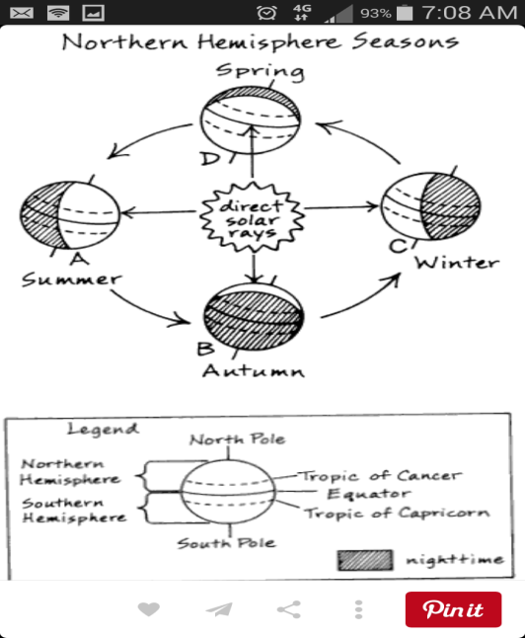

11- Explain the difference between a solar and a lunar eclipse.

SaME: Solar: sun—moon---Earth

Moon casts a shadow on the Earth

LEM: Lunar: sun---Earth—moon

Earth casts a shadow on the moon

12- Analyze data to identify events associated with

heat convection (current) in the atmosphere.

Sun heats air—warm air rises---cools—cold air sinks:

convection current …Happens in atmosphere ( air)

13- Recognize the connection between the sun’s energy and the wind.

Sun heats air…heated air moves/circulates: (moving air) = wind

14- Describe how temperature differences in the ocean account for currents.

Sun warms OCEAN water from surface to 200 meter deep and

Deep sea trenches warm water below 200 meter to ocean floor

Both circulate: warm water (rise) and cold (sink) water…current

15-Interpret meteorological data to make predictions about the weather.

*Barometer-measures air pressure…

A rising or HIGH barometric reading means

GOOD, sunny dry weather,

while a LOW or falling, barometric reading means

stormy and WET, BAD weather

The difference in air pressure is caused by the difference

in temperature.

*A HYGROMETER measures the Humidity is the TOTAL water vapor

the air can hold

*A SLING PSYCHROMETER measures relative humidity

--Relative humidity is the amount of humidity the air is holding

compared to the amount of humidity the air can hold

*An ANEMOMETER measures wind speed

* LOCAL WINDS…Local Breezes

Land Breeze (nite) - wind blows from the land out to sea…

happens at night

Sea Breeze (day)- wind blows from the sea onto land…

happens in daytime

**6 GLOBAL** **Winds…** 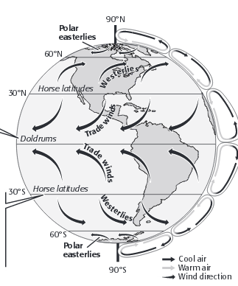

1 Polar Easterlies- 60 to 90°latitude in both hemispheres

In N hemisphere carry cold artic air over US

2 Prevailing Westerlies- found at 30-60° latitude in both hemispheres

blow from west to east produce rain and snow…mainly over US

3 Trade winds- found at 0-30° latitude to the equator in both hemispheres

Blow and curve to west in NH and to the East in the SH…used for trade

4 Doldrums—weak winds **at** the equator 0°

5 Horse latitudes- found **at** 30° north and south of the equator

-transport horses from Europe to America…weak winds

6 Jet stream-narrow belts of high speed winds in the upper troposphere and lower stratosphere…pilots use (30 min faster) from West coast to East coast…

max winds 400 mph

Fronts-boundaries between air masses

* Cold front-cold air pushes warm air up-thunderstorms, heavy rain or snow
* Warm front-warm air moves over cold air- drizzly rain followed by clear warm weather
* Stationary front-cold air mass meets warm air mass; sits still; brings cloudy, wet weather
* Occluded-warm air mass caught between two cold air masses-rain and snow

16- Distinguish among gravitational potential energy, elastic potential energy, and chemical potential energy.

*Potential energies-reserved/stored energy…no action

*Gpe (gravitational potential energy) -based on an object’s height (gravity)

*Epe (elastic potential energy)- energy with the ability to stretch

*Cpe (chemical potential energy) – energy stored in the chemical bonds

of a compound and it changes as the atoms rearrange

*Npe (nuclear potential) energy stored in the nucleus of the atom: fission and fusion

17- Interpret the relationship between potential and kinetic energy.

Stored or on reserve (potential energy) changes into kinetic energy (energy of motion)

18- Recognize that energy can be transformed (changed into a new kind)

from one type to another.

From chemical (battery) to light, sound and heat (game)

From Mains (power plant) to light, heat and sound (T.V.)

From chemical (food) to heat, sound and movement (you)

19- Explain the Law of Conservation of Energy using data from a variety of energy transformations.

Law: energy can only be transformed; not created or destroyed

EX: Chemical energy (Pe) in a match is changed into sound, heat and light (ke)

***The energy **we are using now** is the **same** energy that the Indians used;

is the **same** energy that the Romans used; is the **same** energy used

by the cavemen.

20- Identify how simple circuits are associated with the transfer of electrical energy when heat, light, sound, and chemical changes are produced.

21- Identify materials that can conduct electricity.

Metals: iron, copper, gold, aluminum, etc.

22- Design a simple experimental procedure with an identified control and appropriate variables.

23- Select tools and procedures needed to conduct a moderately complex experiment.

24- Interpret and translate data into a table, graph, or diagram.

25- Draw a conclusion that establishes a cause and effect relationship supported by evidence.

26- Identify a faulty interpretation of data that is due to bias or experimental error.

Bill is assigned by his editor to determine what most Americans think about a new law that will place a federal tax on all modems and computers purchased. The revenues from the tax will be used to enforce new online decency laws. Bill, being technically inclined, decides to use an email poll. In his poll, 95% of those surveyed opposed the tax. Bill was quite surprised when 65% of all Americans voted for the taxes.

The United Pacifists of America decide to run a poll to determine what Americans think about guns and gun control. Jane is assigned the task of setting up the study. To save mailing costs, she includes the survey form in the group's newsletter mailing. She is very pleased to find out that 95% of those surveyed favor gun control laws and she tells her friends that the vast majority of Americans favor gun control laws.

Large scale polls were taken in Florida, California, and Maine and it was found that an average of 55% of those polled spent at least fourteen days a year near the ocean. So, it can be safely concluded that 55% of all Americans spend at least fourteen days near the ocean each year.

27- Identify the tools and procedures needed to test the design features of a prototype

28- Evaluate a protocol to determine if the engineering design process was successfully applied.

29- Distinguish between the intended benefits and the unintended consequences of a *new* technology… explain…

* Spraying pesticide on crops…intended benefit: Pesticide to kill bugs that are eating crops; Unintended consequence: soaked into the ground and ran into lakes poisoning fish
* 1990 Motorcycle helmets and motorcyclists…Intended Benefit: reduction in the number of head injuries, Unintended Consequence: there was also an unintended reduction in the number of juvenile cyclists (sells went down)

30- Differentiate between adaptive and assistive engineered products.

Adaptive- specifically designed for people with disabilities

EX: Cochlear Implant, Lasik, Heart Transplant, artificial limbs: legs, arms

Assistive- designed for general population; but, can be used by people with disabilities

EX: Eyeglasses, canes, dentures, Wheelchairs

