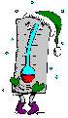
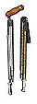
Weather Instruments
A THERMOMETER measures the air temperature. Most thermometers are closed glass tubes containing liquids such as alcohol or mercury. When air around the tube heats the liquid, the liquid expands and moves up the tube. A scale then shows what the actual temperature is.
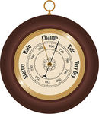A BAROMETER measures air pressure. It tells you whether or not the pressure is rising or falling. A rising barometer means sunny and dry conditions, while a falling barometer means stormy and wet conditions. An Italian scientist named Torricelli built the first barometer in 1643.
A SLING PSYCHROMETER measures relative humidity, using the cooling effect of evaporation. Two thermometers are used in a sling psychrometer. Wet the cloth of one of the thermometers and swing the psychrometer around a few times. Water evaporates from the cloth, causing the temperatures on that thermometer to be lower the other.
A RAIN GAUGE measures the amount of rain that has fallen over a specific time period.
A WIND VANE is an instrument that determines the direction from which the wind is blowing.
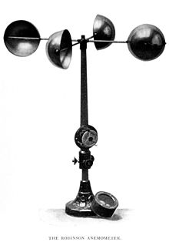
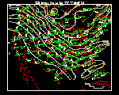
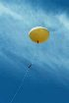
An ANEMOMETER measures wind speed. The cups catch the wind, turning a dial attached to the instrument. The dial shows the wind speed.
WEATHER MAPS indicate atmospheric conditions above a large portion of the Earth's surface. Meteorologists use weather maps to forecast the weather.
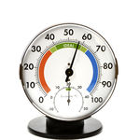A HYGROMETER measures the water vapor content of air or the humidity.
A WEATHER BALLOON measures weather conditions higher up in the atmosphere.
A COMPASS is a navigational instrument for finding directions.
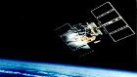
WEATHER SATELLITES are used to photograph and track large-scale air movements. Then meteorologists compile and analyze the data with the help of computers.
YOUR EYES are one of the best ways to help detect the weather. Always keep an eye at the sky and you'll usually be on top of weather conditions.

